高通量定序作業

學號: M0701123
姓名: 黃蘅軒

- How many species
Answer: 265

- Mature miRNA length distribution by species? (hsa, mmu, gga, plant)

Hsa

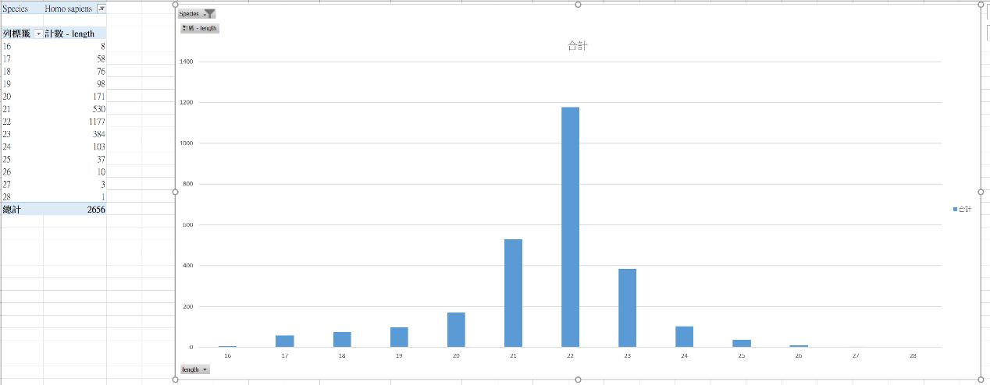

Mmu

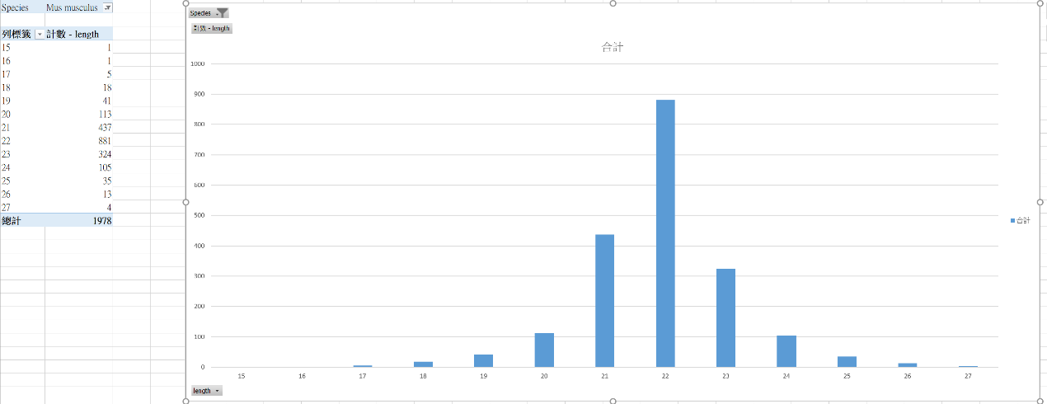

Gga

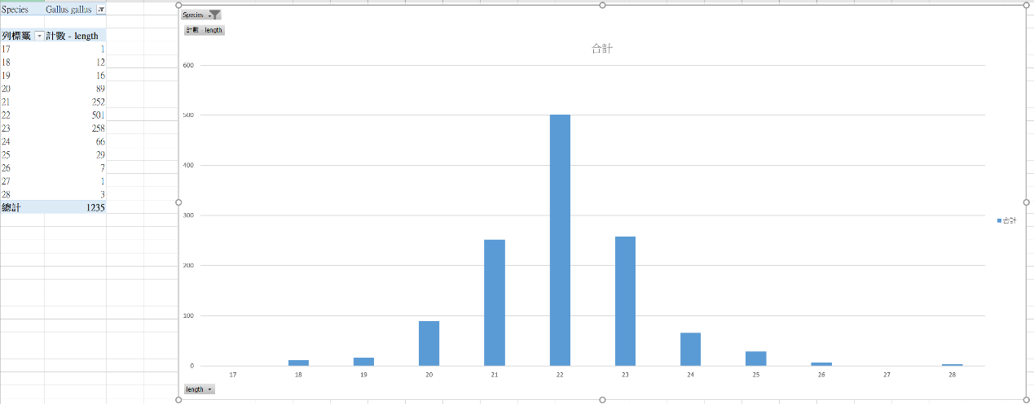

Plant

